Task 3: Visualization and Interpretation
Name: Shafaque Naushad
Course: B.Sc. Life Science (Pursuing)
Internship: Bioinformatics Internship
Intern Id: SWX-2026-001799
Task: Biological Dataset Selection
Date: 10 October 2026
Dataset: Single-cell barcode quality summary

1. Objective
The aim of this task is to visualize the basic quality-related measurements obtained in Task 2 and interpret what the charts show and do not prove.
2. Chart 1: Distribution of Total Counts per Barcode
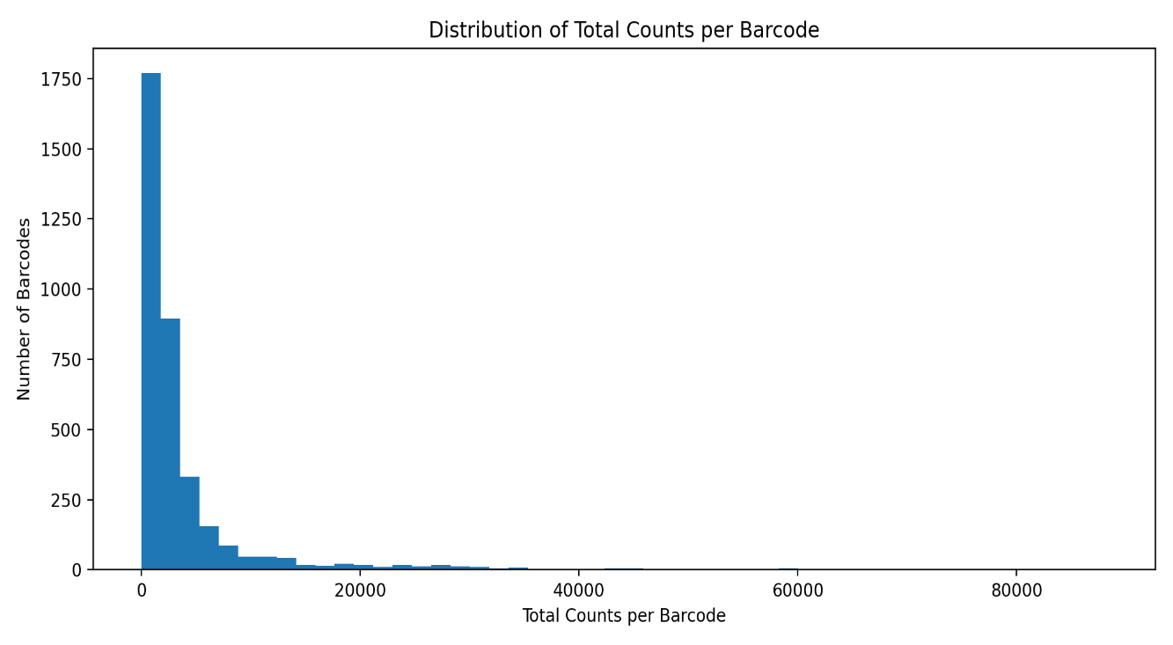
Interpretation: The histogram shows the distribution of total counts across the barcodes. The distribution is right-skewed, with most barcodes having lower total counts and a smaller number having much higher counts. The mean total count is 4,154.33, while the median is 1,792.
What it shows: It shows how total counts vary among the barcodes and whether the values are concentrated in a particular range.
What it does not prove: The chart does not by itself prove that a barcode with more counts is biologically better, that a barcode with fewer counts is poor quality, or what caused the observed differences.
3. Chart 2: Distribution of Detected Genes per Barcode
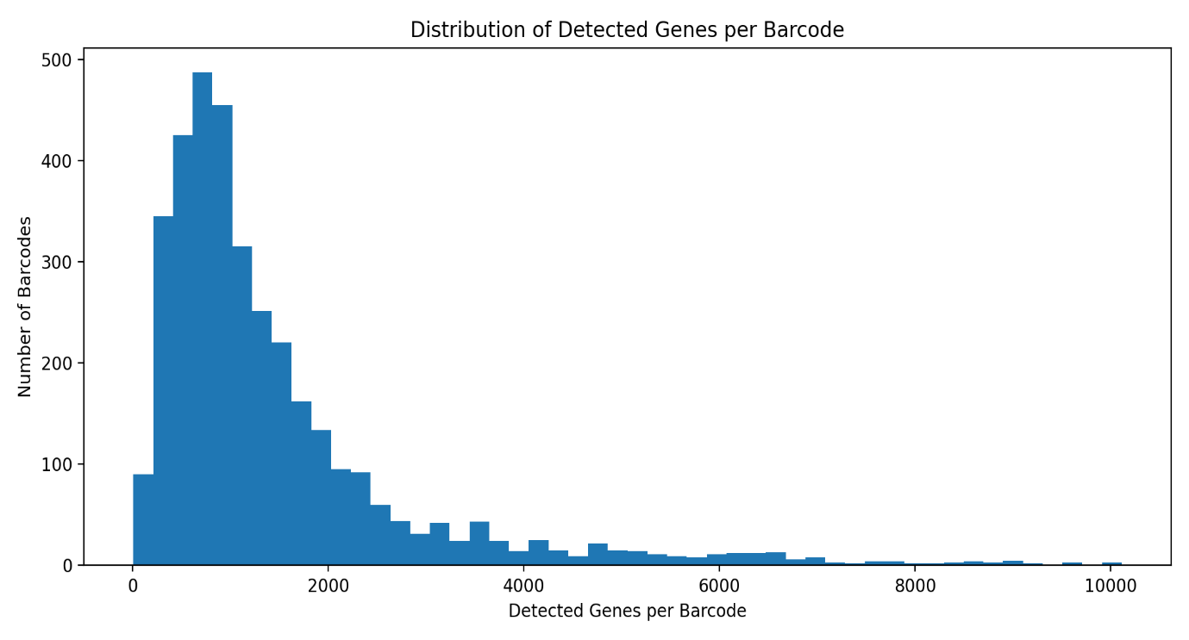
Interpretation: The histogram shows the number of genes detected in each barcode. Most barcodes are concentrated toward the lower range, while a smaller number have much higher numbers of detected genes. The mean is 1,483.16 genes and the median is 1,015 genes.
What it shows: It shows the distribution and variation of detected-gene counts among the barcodes.
What it does not prove: The chart does not by itself prove that barcodes with more detected genes are biologically better, that a low value is necessarily poor quality, or that the differences are caused by a particular biological process.
4. Overall Interpretation
The dataset contains 3,585 barcodes. Both visualizations show right-skewed distributions, with most observations concentrated at lower values and a smaller number of high-value observations. These charts are useful for describing the distribution of the measurements, but they should not be used alone to make biological or causal conclusions.

5. Conclusion
Visualization makes it easier to understand the distribution and variation present in the dataset. The charts identify patterns such as concentration and skewness, but further analysis would be required to determine the biological meaning or causes of these patterns.

